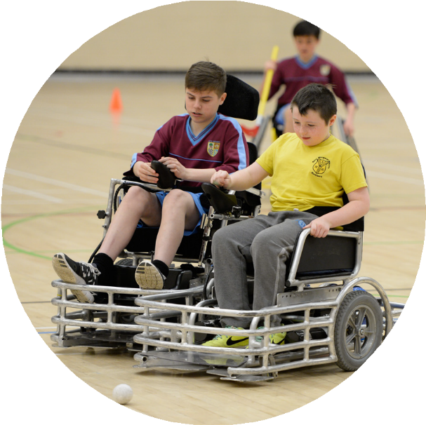
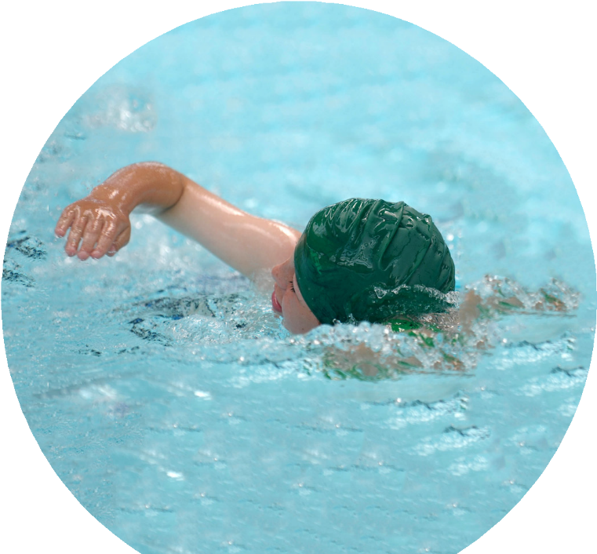
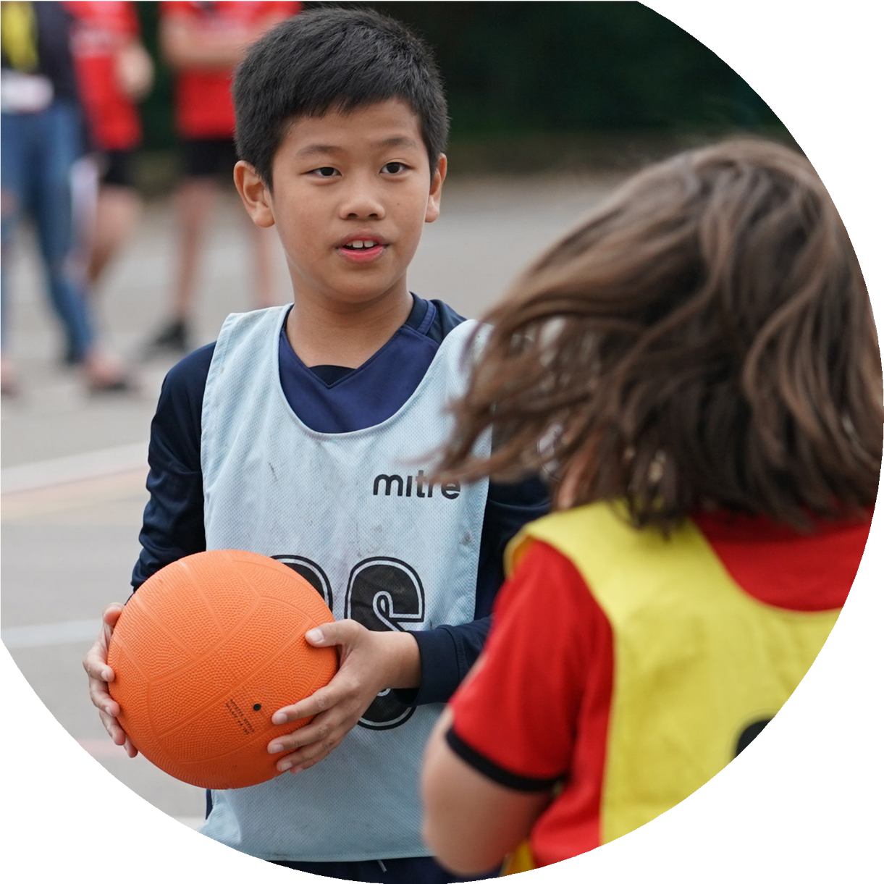

Evidencing the impact of the Primary PE and sport premium

North Duffield Community Primary School

Commissioned by

Created by

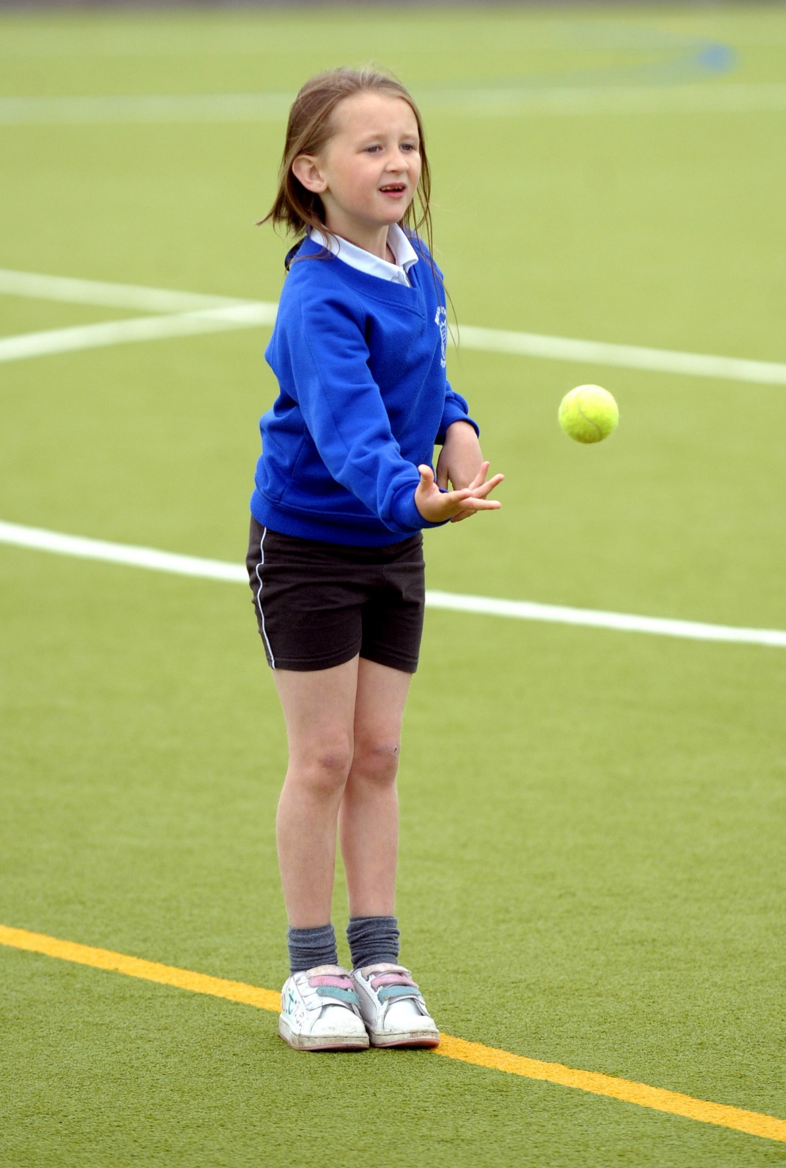
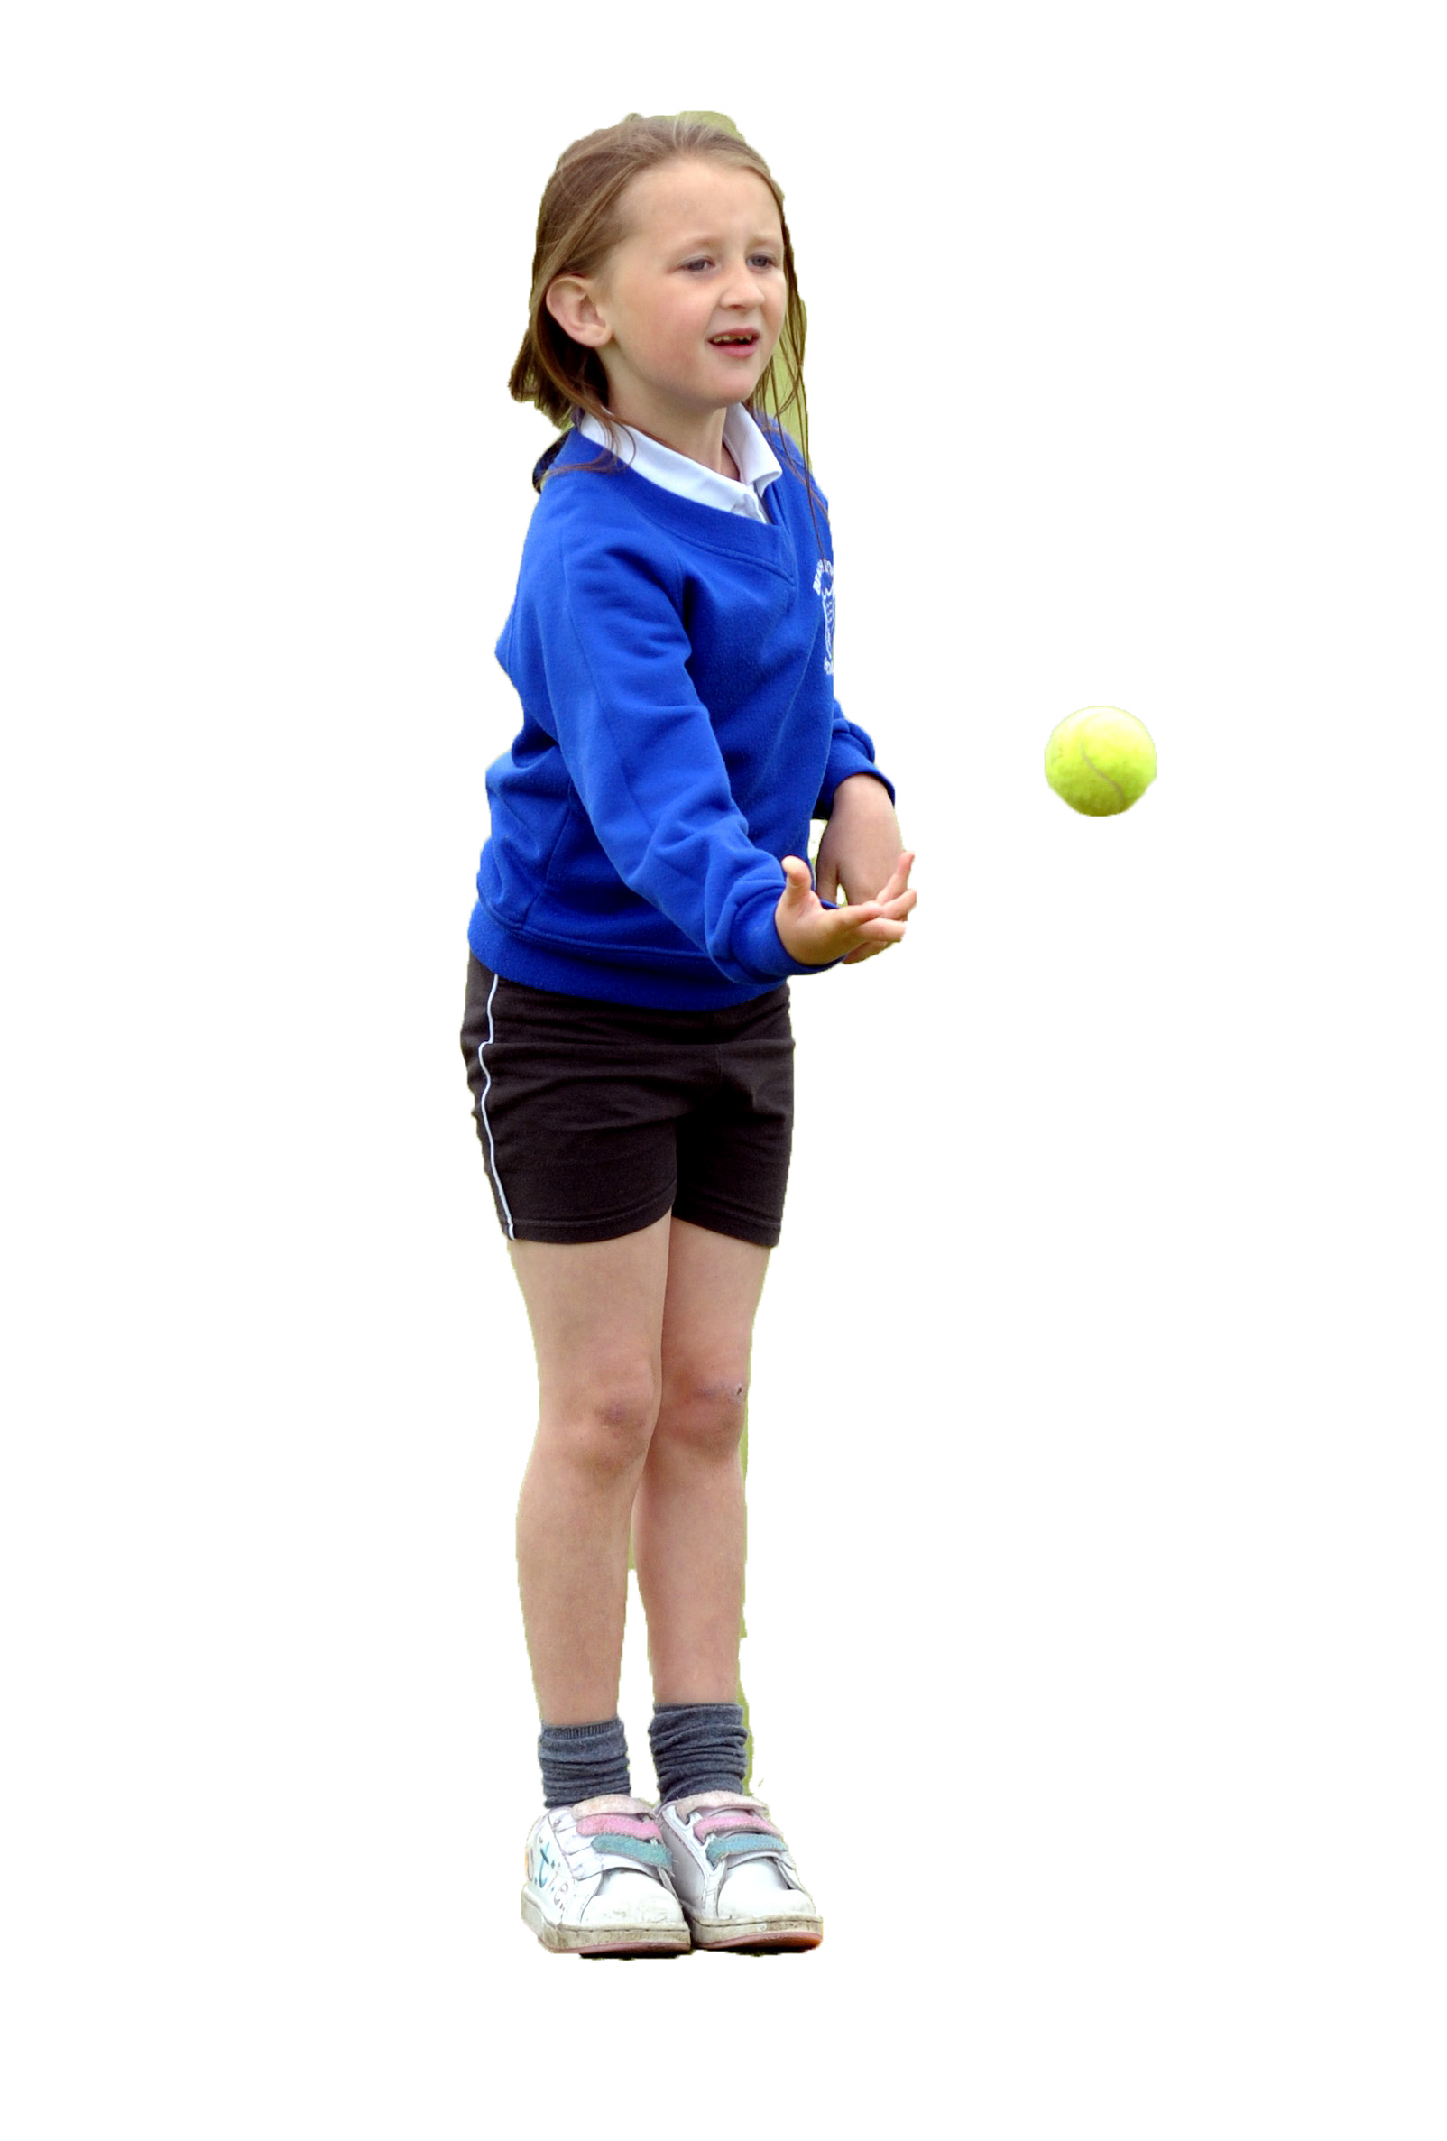

It is important that your grant is used effectively and based on school need. The Education Inspection Framework makes clear there will be a focus on ‘whether leaders and those responsible for governors all understand their respective roles and perform these in a way that enhances the effectiveness of the school’.

Under the Quality of Education Ofsted inspectors consider:
Intent - Curriculum design, coverage and appropriateness
Implementation - Curriculum delivery, Teaching (pedagogy) and Assessment
Impact - Attainment and progress

To assist schools with common transferable language this template has been developed to utilise the same three headings which should make your plans easily transferable between working documents.

Schools must use the funding to make additional and sustainable improvements to the quality of Physical Education, School Sport and Physical Activity (PESSPA) they offer. This means that you should use the Primary PE and sport premium to:

- Develop or add to the PESSPA activities that your school already offer
- Build capacity and capability within the school to ensure that improvements made now will benefit pupils joining the school in future years
- The Primary PE and sport premium should not be used to fund capital spend projects; the school’s budget should fund these.

Pleasevisitgov.ukfortherevisedDfEguidanceincludingthe5keyindicatorsacrosswhichschoolsshoulddemonstrate animprovement.Thisdocumentwillhelpyoutoreviewyourprovisionandtoreportyourspend.DfEencouragesschools to use this template as an effective way of meeting the reporting requirements of the Primary PE and sport premium.

We recommend you start by reflecting on the impact of current provision and reviewing the previous spend.

Schools are required to publish details of how they spend this funding, including any under-spend from 2019/2020, as well as on the impact it has on pupils’ PE and sport participation and attainment. All funding must be spent by 31st July 2022.

We recommend regularly updating the table and publishing it on your website throughout the year. This evidences your ongoing self-evaluation of how you are using the funding to secure maximum, sustainable impact. Final copy must be posted on your website by the end of the academic year and no later than the 31st July 2021. To see an example of how to complete the table please click HERE.
Created by: Supported by:

Details with regard to funding
Please complete the table below.

Total amount carried over from 2019/20 | £ 5972.68
Total amount allocated for 2020/21 | £ 17090
How much (if any) do you intend to carry over from this total fund into 2021/22? | £ 6299
Total amount allocated for 2021/22 | £ 17069
Total amount of funding for 2021/22. To be spent and reported on by 31st July 2022. | £ 23368
Swimming Data
Please report on your Swimming Data below.

Meeting national curriculum requirements for swimming and water safety.  N.B. Complete this section to your best ability. For example you might have practised safe self-rescue techniques on dry land which you can then transfer to the pool when school swimming restarts.  Due to exceptional circumstances priority should be given to ensuring that pupils can perform safe self rescue even if they do not fully meet the first two requirements of the NC programme of study | 88%
What percentage of your current Year 6 cohort swim competently, confidently and proficiently over a distance of at least 25 metres?  N.B. Even though your pupils may swim in another year please report on their attainment on leaving primary school at the end of the summer term 2021.  Please see note above | 88%
What percentage of your current Year 6 cohort use a range of strokes effectively [for example, front crawl, backstroke and breaststroke]?  Please see note above | 88%
What percentage of your current Year 6 cohort perform safe self-rescue in different water-based situations? | 88%
Schools can choose to use the Primary PE and sport premium to provide additional provision for swimming but this must be for activity over and above the national curriculum requirements. Have you used it in this way? | No

Action Plan and Budget Tracking
Capture your intended annual spend against the 5 key indicators. Clarify the success criteria and evidence of impact that you intend to measure to evaluate for pupils today and for the future.

Academic Year: 2020/21 | Total fund allocated: | Date Updated:
Key indicator 1: The engagement of all pupils in regular physical activity – Chief Medical Officers guidelines recommend that primary school pupils undertake at least 30 minutes of physical activity a day in school |  |  |  | Percentage of total allocation:
 |  |  |  | 26%
Intent | Implementation |  | Impact
Your school focus should be clear what you want the pupils to know and be able to do and about  what they need to learn and to  consolidate through practice: | Make sure your actions to achieve are linked to your intentions: | Funding allocated: | Evidence of impact: what do pupils now know and what can they now do? What has changed?: | Sustainability and suggested next steps:
- Provide resources and areas for the children to access physical activity throughout the day.  - Majority of children are accessing 30 minutes physical activity in school, through organised or self initiated activities. | Playground Markings- for fitness Promote active areas- monitor use.  Put plan in place for use of health activities during the day.  Develop OAA and Active learning activities in the forest school area.  Build an area for resources to be stored and access for the children.  New resources for playground- basketball hoop, trails. (Pupil Research)  PE leader time to investigate Active School Status.  Action Plan for developing as an Active School. | £6016.29 | Pupils have now got extra access to resources that they are able to use at break time.  Observations show that the majority of pupils in school are undertaking at least 30 minutes physical activity a day, especially when outside.  OAA and forest school (until covid and lockdowns) used with KS1 pupils to promote healthy living.  Less stationary pupils at break and lunchtimes. | Sports Leader to be taught how to use the areas to develop activities during break and lunch time.  Target identified pupils to use the areas with the sports leaders.  Involve Sports Leaders and School Council in developing a way to promote the areas and how to use them.  Use of the school’s forest school area is promoted throughout KS1.  Questionnaire for pupils on how to keep momentum of activities and resources to use at break time.  Budget to be used to develop Broadmanor playground as an extension of the exercise area, providing more opportunities
Key indicator 2: The profile of PESSPA being raised across the school as a tool for whole school improvement |  |  |  | Percentage of total allocation:
 |  |  |  | 0%
Intent | Implementation |  | Impact
Your school focus should be clear what you want the pupils to know and be able to do and about  what they need to learn and to  consolidate through practice: | Make sure your actions to achieve are linked to your intentions: | Funding allocated: | Evidence of impact: what do pupils now know and what can they now do? What has changed?: | Sustainability and suggested next steps:
 | Active maps to be completed by staff  Monitor children’s access 30:30 PE daily CPD for all staff on 30:30 initiative.  Generate opportunities for children to access PE daily. Monitor impact on children.  Action Plan for achieving Gold Games Standard  Review Assessment Data and develop areas for action | £0 | This area was difficult to measure in 2020-21 due to lockdowns and the need for extra restrictions in school.  Pupils did participate in activities provided by North Yorkshire Sports | To ensure assessment system is in place.  Monitoring of PE is rigorous and provided information for the next steps in the subject.  School Games is recorded at least half termly on the system by the PE lead.  More access to online activities as well as intra and inter competitions

Key indicator 3: Increased confidence, knowledge and skills of all staff in teaching PE and sport |  |  |  | Percentage of total allocation:
 |  |  |  | 8%
Intent | Implementation |  | Impact
Your school focus should be clear what you want the pupils to know and be able to do and about  what they need to learn and to  consolidate through practice: | Make sure your actions to achieve are linked to your intentions: | Funding allocated: | Evidence of impact: what do pupils now know and what can they now do? What has changed?: | Sustainability and suggested next steps:
Curriculum needs to show progress and have an effective system of assessment.  Curriculum mapping and new scheme needs to be embedded with the use of CPD from trained individuals. | Purchase Complete PE  Staff Meeting to explore Complete PE and how to implement  Introduce and monitor assessment of PE through the scheme purchased.  Questionnaire for staff and children using Complete PE.  Record children’s activity outside school- develop sports board to celebrate successes in and out of school | £1921.43 | New scheme recommended by Youth Sports Trust purchased  Whole school curriculum map in place.  Staff are using planning for their classes to deliver curriculum  New sports are delivered by coach as part of CPD for staff (handball, Kurling, Boccia etc..) | Due to lockdown questionnaire not completed, will be done as part of monitoring in Spring 2022.  Staff are teaching PE confidently with children demonstrating progress.  Assessment system and information are used to promote and evaluate curriculum.  Swimming CPD to be provided in 2021-22 to enable school staff to teach swimming at local pools.  Investigate further training within OAA and Forest School Initiative, providing school staff with onsite training.
Key indicator 4: Broader experience of a range of sports and activities offered to all pupils |  |  |  | Percentage of total allocation:
 |  |  |  | 32%
Intent | Implementation |  | Impact
Your school focus should be clear what you want the pupils to know and be able to do and about  what they need to learn and to  consolidate through practice: | Make sure your actions to achieve are linked to your intentions: | Funding allocated: | Evidence of impact: what do pupils now know and what can they now do? What has changed?: | Sustainability and suggested next steps:
Additional achievements:  Provision of physical activity is not restricted to traditional sports.  School promotes all activities to include all children. | Employ coaches to work alongside PE lead with pupils. PE lead to run CPD for staff  Monitoring of curriculum shows variety of sports played and inclusion of all children.  New sports to be investigated and brought into school by PE Lead and Sports Councilors.  Develop links with clubs, coaches in school and outside school hours.  Upgrade gymnastics equipment in the hall. (benches, mats and ropes).  Promote Inclusive Sports through Quidditch, Tri Golf, Archery and Kurling- purchase resources for sustainability | £7201.38 | Sports coaches have provided different sports this year.  PE lead has promoted these sports in lessons ensuring all pupils are included | New sports are part of the new PE curriculum map.  Pupils to participate in cross school competitions, when permitted.  CPD for all staff to disseminate new sports and teach them in class.  Equipment is constantly updated, all new sports have resources enabling them to be taught by staff in 2021-22.  OAA to be developed as part of the new scheme and CPD provided if necessary.  Links to clubs to be forged again this year, covid permitting. (Tennis, Golf, Football, Rugby, Archery, Running etc…)  Gymnastics equipment to be upgraded.

Key indicator 5: Increased participation in competitive sport |  |  |  | Percentage of total allocation:
 |  |  |  | 6%
Intent | Implementation |  | Impact
Your school focus should be clear what you want the pupils to know and be able to do and about  what they need to learn and to  consolidate through practice: | Make sure your actions to achieve are linked to your intentions: | Funding allocated: | Evidence of impact: what do pupils now know and what can they now do? What has changed?: | Sustainability and suggested next steps:
Every child I school has participated in a cluster event.  Increase the number of intra school competitions to allow more participation. | To have maximum attendance at cluster sports events.  Enable all children to access inter school competitive and non competitive sports.  Allow children displaying sporting talent to participate against children in area and county finals. Promote Intra school activities during PE sessions.  Achieve Gold School Games Standard.  Ensure all children can access cluster events.  Staffing costs for the events (safety)  Cost of coaches to allow all children to access events. | £1300 | Due to covid and lack of cross school and cluster events this area was not covered as well during the year.  School did hold virtual kurling and ultimate challenger events with NY sports  Kurling, boccia and football class tournaments were permitted and held as well. | To ensure, when permitted, pupils participate in competitive sports.  Develop competitive sports as part of the new scheme.  If safe, cluster events are participated in.

Signed off by
Head Teacher: | A Russell
Date: | November 2021
Subject Leader: | A Russell
Date: | November 2021
Governor: | G Dixon
Date: | November 2021

