Progression
0
North Duffield community primary school
N
 | Computing systems and networks | Programming | Data and information | Creating media
themes
Taxonomy strands | Computer systems | Programming | Data and information | Creating media
 |  | Algorithms
 | Computer |  |  | Design and
 | networks | Design and |  | development
 |  | development
 | Effective use of tools
 | Impact of technology
 | Safety and security

Progression across key stages

All learning objectives have been mapped to the National Centre for Computing Education’s taxonomy of ten strands, which ensures that units build on each other from one key stage to the next.

Progression across year groups

Within the Teach Computing Curriculum, every year group learns through units within the same four themes, which combine the ten strands of the National Centre for Computing Education’s taxonomy (see table, right).

This approach allows us to use the spiral curriculum approach (see the ‘Spiral curriculum’ section for more information) to progress skills and concepts from one year group to the next.

Primary

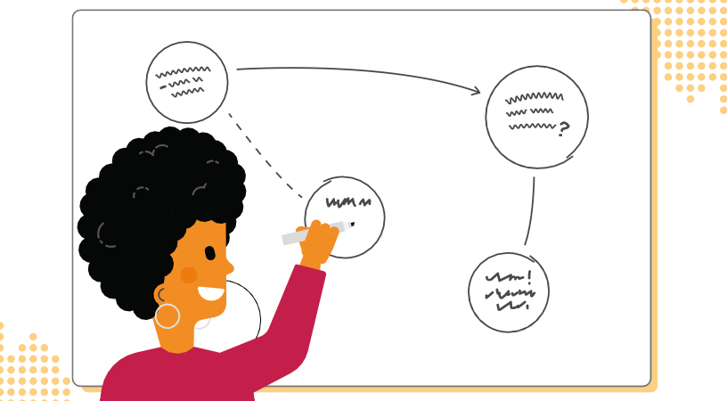
Progression within a unit — learning graphs
Learning graphs are provided as part of each unit and demonstrate progression through concepts and skills. In order to learn some of those concepts and skills, pupils need prior knowledge of others, so the learning graphs show which concepts and skills need to be taught first and which could be taught at
a different time.

The learning graphs often show more statements than there are learning objectives. All of the skills and concepts learnt are included in the learning graphs. Some of these skills and concepts are milestones, which form learning objectives, while others are smaller steps towards these milestones, which form success criteria. Please note that the wording of the statements may be different in the learning graphs than in the lessons, as the learning graphs are designed for teachers, whereas the learning objectives and success criteria are age-appropriate so that they can be understood by pupils.

In each year group, there are two ‘Programming’ units of work, but only one ‘Programming’ learning graph. The second ‘Programming’ unit builds on the

content that was taught in the first ‘Programming’ unit so closely that there is no specific divide where one ends and the other begins.

Key

Concept

Skill

Y2 – Data and Information – Pictograms learning gra
To use a tally chart to collect data
To recognise that people, animals and objects can be described by attibutes
To compare objects that have been grouped by attribute
To complete a given comparison question
To use a computer to view data in different formats
To use a computer to answer comparison questions (graphs, tables)
To use a computer program to present information in different ways
To show I can enter data onto a computer
To suggest appropriate headings for tally charts and pictograms
To give simple examples of why some information should not be shared
To use pictograms to answer single-attribute questions
To explain that we can present information using a computer

